HSE Monthly Report – January 2026
Weyland Energy – all sites
Hannah Weber · 09 February 2026 · HSE-RPT-2026-01

1. Headlines
On 14 January turbine T-07 at Kestrel Ridge failed (KR-INC-2026-003). There were no injuries; about 4 litres of gearbox oil were contained in the nacelle drip tray and recorded as a minor environmental incident (HSE-INC-2026-002). The crane lift for the gearbox exchange is planned for early February – HSE will review the lift plan.
Indicator | January | YTD 2026 | 2025
Hours worked | 126,000 | 126,000 | 1,452,000
Lost time injuries | 0 | 0 | 2
Recordable injuries | 0 | 0 | 6
First aid cases | 5 | 5 | –
Near misses | 28 | 28 | 307
Safety observations | 200 | – | –
LTIFR rolling 12 months | 1.37 | – | 1.38
TRIR rolling 12 months | 4.11 | – | 4.13

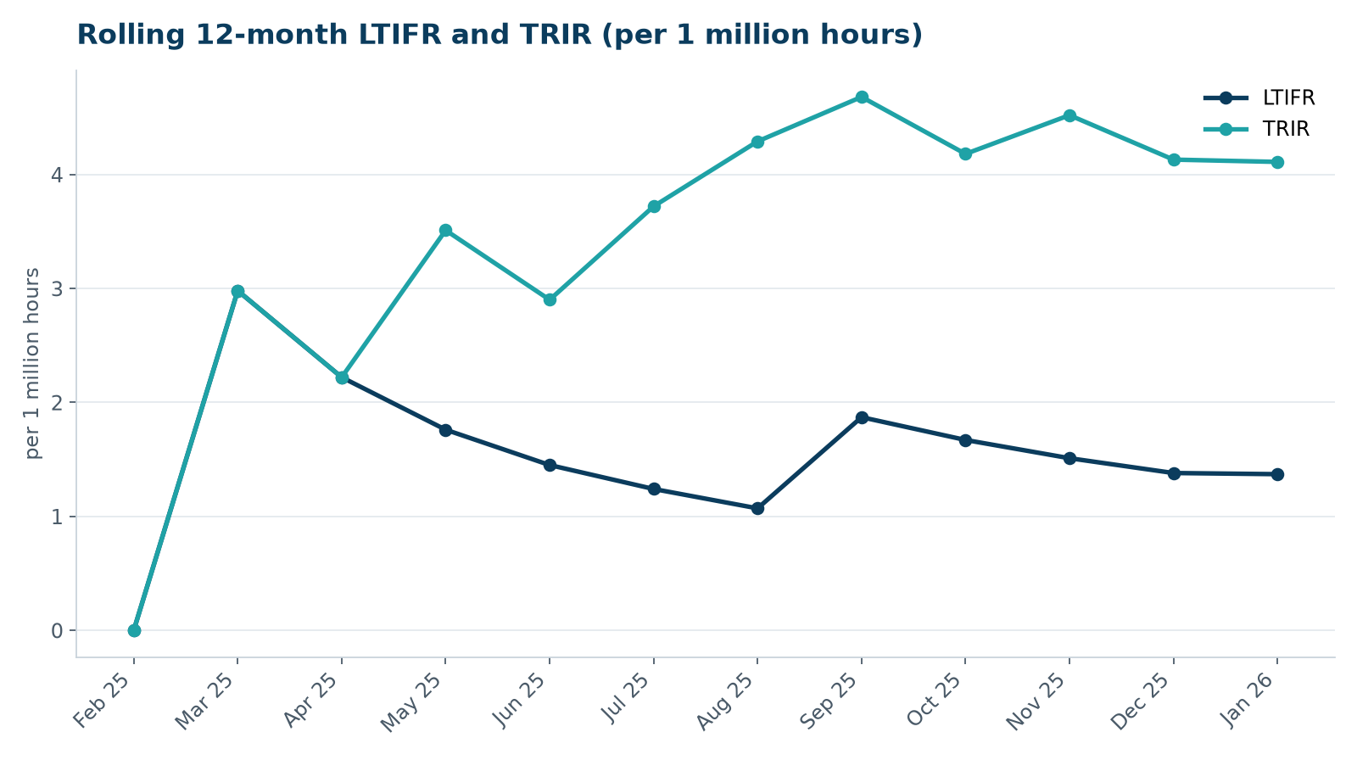

2. Hours by group
Group | Hours | Share
Weyland employees | 61,000 | 48 %
O&M contractors (operating assets) | 37,000 | 29 %
Harrow Bay contractors | 28,000 | 22 %

3. Leading indicators
- Toolbox talks delivered: 95
- Management safety walks: 14 (target 12)
- Inspections of lifting equipment: 41
- Open corrective actions older than 30 days: 11

4. Focus for next month
Fatigue management for offshore crews during long weather windows.
Hannah Weber, HSE Manager

